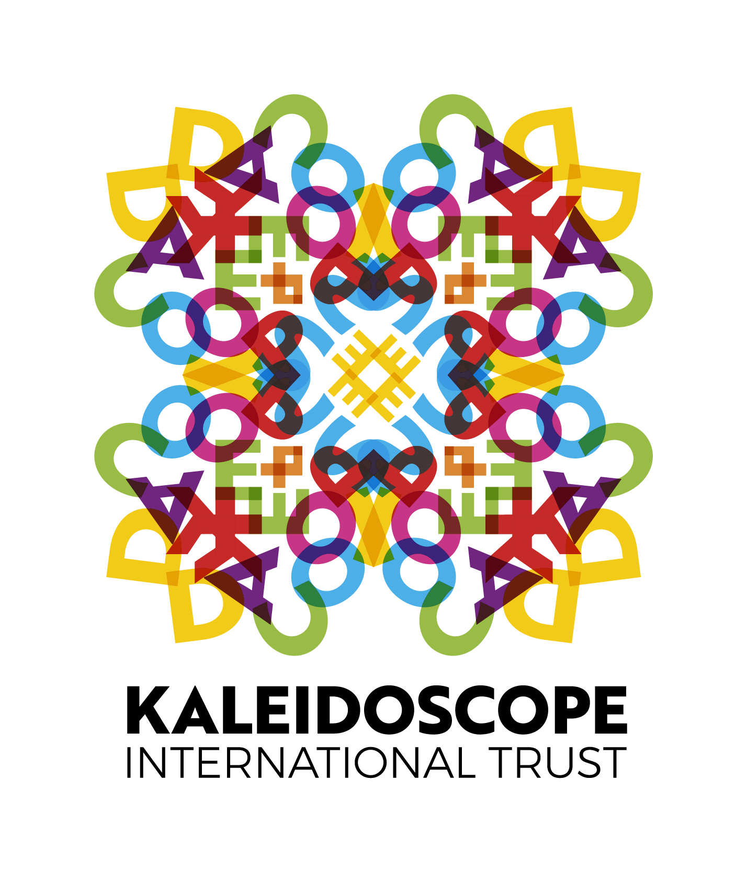
CALL FOR EXPERTS:
CAPACITY DEVELOPMENT INTERVENTIONS (CDI)
FOR LGBTI+ ORGANISATIONS IN
COMMONWEALTH GLOBAL SOUTH AND EAST COUNTRIES

Submission Deadline: 11:59pm GMT 18 February 2024

Background:

Established in 2011, Kaleidoscope Trust is a UK-based charity focused on fighting for the human rights of lesbian, gay, bisexual, transgender, intersex and gender diverse (LGBTI+) people across the Commonwealth and beyond. We fund, fight for and empower those upholding the human rights of LGBTI+ people by working with governments, change-makers and civil society organisations to effect meaningful and lasting change in the lives of LGBTI+ people everywhere.

In line with our vision towards a free, safe and equal world for LGBTI+ people everywhere, KT designs and implements programmes that seek to create lasting change for our communities globally. We deliver funding, resources, technical support, platforms, and connections to ensure the long-term sustainability and effective advocacy of organisations defending the human rights of LGBTI+ people. This also includes providing opportunities for learning, sharing, strategising and building the global movement for LGBTI+ individuals and their allies striving to improve their advocacy strategies nationally, regionally or internationally. To date, KT has supported an estimated 120 civil society organisations (CSOs) in 41 countries around the world through resource mobilisation, and capacity development opportunities. In addition to this, KT has provided over 35 capacity development interventions (CDIs) to over 60 CSOs under various projects to support their ongoing capacity to protect and defend LGBTI+ rights.

At this time, KT has secured two different pots of funding from our institutional donors to continue our work providing Commonwealth-based LGBTI+ CSOs with the technical capacity and expertise they require to sustain and advance their work locally, regionally, and internationally. While both programmes share the common goal of advancing LGBTI+ rights – emphasising the importance of advocacy efforts to bring about positive changes in law, policy, and societal attitudes towards LGBTI+ individuals – they differ in their geographic focus, approach to advocacy, emphasis on intersectionality, and the specific outcomes they aim to achieve.

Supporting LGBTI+ Rights and Growth Efforts (S.U.R.G.E.)  - Has a broader geographical spread - considers a global approach with an emphasis on Africa and the Americas.  - Emphasis on strengthening and equipping LGBTI+ organisations with technical resources for effective and impactful advocacy in an environment characterised by long-standing deprivation or abrupt rollback of rights.  - Its overall goal is creating positive changes in law and policy, increased access to decision making spaces and greater recognition and acceptance of LGBTI+ lived realities. | Respect, Mainstreaming and Realisation of LGBT+ Rights in the Commonwealth (RMR)  - Specifically targets organisations in Asia and the Pacific.  - Focuses on intersectional advocacy as an avenue to secure LGBTI+ rights, acknowledging the interconnected nature of diverse social identities such as gender, sexuality, race, and class.  - It zooms into the provision of tailored support to LGBTI+ civil society organisations and allied social justice groups to advance the rights of LGBTI+ people and other disadvantaged groups.

In line with our strategy, and learning from previous CDI schemes delivered since 2020, KT is building a roster of thematic experts whose knowledge and expertise can help us deliver these capacity building initiatives in benefit of LGBTI+ communities. More information of the scope of work, the specific areas of knowledge and requirements can be found below.

Scope of Work:

KT is seeking consultants or consultancy teams to conduct short-term, focused Capacity Development Interventions with the very clear objective of benefiting LGBTI+ CSOs in Commonwealth Global South and East countries in areas of knowledge that have been prioritised by LGBTI+ organisations themselves. The goal is for thematic experts (consultants and/or consultancy teams) to co-design and deliver customised online one-on-one CDI sessions that will enhance the capacity and cultivate the skills of these organisations in advocating for LGBTI+ rights.

By engaging a multidisciplinary cohort of consultants and/or consultancy teams, we anticipate a two-fold outcome: tap into the expertise of thematic leads to address organisational learning and development needs of LGBTI+ organisations in a holistic way, and expand KT's toolbox of capacity development resources for the future. This, in turn, will support LGBTI+ organisations in Global Commonwealth South and East countries, reinforcing our commitment to their cause. It must be noted that recipient organisations have not been identified yet. Once the roster of experts and proposed interventions has been finalised, a separate call will be released among prospective LGBTI+ organisations in order to match their needs with the available expertise.

Key themes prioritised under this call for experts have been identified by KT through our most recent Learning and Development Needs Assessment (LDNA), based on feedback from 100+ LGBTI+ organisations (and more than 40 other stakeholders) across 39 countries, and a series of consultations with partners during recent Scoping Missions in Southern Africa and South-East Asia. This assessment highlights crucial areas of knowledge, skills, and resources that these organisations deem essential for effective work. Based on this rich source of insights, we are inviting proposals for capacity development interventions in any one or more of the following key streams and/or sub-themes suggested within each of the streams:

Themes common to both streams | S.U.R.G.E.-specific stream | RMR-specific stream

- Governance and organisational health and development, including but not limited to:
  - financial management, including project and/or organisational budgeting, accounting and financial online systems.
  - organisational fundraising and income diversification.
  - organisational leadership and management, including good governance and institutional building, effective use of free digital tools (e.g., Google services, GIS, Kobo toolbox, Trello, and Canva).
  - staff/volunteer wellbeing support and retention management, including burnout prevention, self-care, work life balance and mental health first aid.

- Monitoring, evaluation and learning (MEL) and Research, including but not limited to:
  - intersectional, participatory, and community-led MEL and/or research.
  - impact evaluation methods, results frameworks and programme strategies that improve legitimacy, effectiveness and impact of civil society work.
  - effective outcome reporting for donors, trustees, and the LGBT+ community.
  - bespoken MEL tools to support data collection, evaluation and learning, and/or research and programming.
  - effective research dissemination strategies.

- Advocacy and Campaigning, including but not limited to:
  - short-term/long-term advocacy strategy design, including intersectional advocacy strategies.
  - contextual analysis, including understanding contextual threats and opportunities for engagement on national and regional levels.
  - stakeholder analysis and engagement (who, what, where, how, why).
  - legal and policy advocacy, including effective policy and research communication.
  - post legislative scrutiny (PLS) for CSOs, and how to implement or develop PLS for legal reform.
  - strategic litigation and paralegal case management.
  - effective human rights violation recording and data for advocacy.
  - effective media campaigns, including identifying and reaching out to target groups using most appropriate mediums, creating appropriate messaging, combating anti-gender and anti-rights narratives.

- Effective outreach and sensitisation of key stakeholders, including decision makers, with a focus on:
  - facilitation techniques and tools (for in person and online training).
  - effective strategies when engaging with key stakeholders, including building intersectional allyships.
  - detailed content/modules about LGBTI+ populations, including the diversity of the various populations, defining gender, challenging stereotypes, and the impact of stigma and discrimination towards these populations.
  - SOGIESC sensitisation for service providers, media, and police, among others.

- Safety and security, including but not limited to:  - personal, organisational and workplace safety and security, including physical safety, digital data protection, and holistic security strategies.  - digital safety and security tools, including encrypted communication and device protection.  - emergency response and crisis management. | - Effective outreach and engagement with LGBTI+ groups and communities most affected by intersectional discrimination, with a particular focus on:  - geographically isolated people, especially in rural areas.  - disabled people.  - economically deprived or impoverished communities.  - intersex people.  - ethnically marginalised communities.  - migrants, internally displaced persons (IDPs), and refugees.  - elders/ persons of age.  - populations vulnerable to climate change impacts.

The consultants/consultancy teams are welcome to submit their interest to deliver proposals under any one or more of the streams or sub-themes provided above – with a maximum limit of three proposals per consultant/consultancy team. The proposed thematic intervention(s) should be deliverable in a maximum of five days (a total of 40 hours based on 8 hours per day of work) per organisation, including any pre- and post-work for the intervention.
Successful proposals will then be added to a roster of capacity development interventions that Commonwealth LGBTI+ organisations will be able to apply for through an open call to be released between February and March 2024. KT will then match available expertise with recipient organisations. Please see section Timeline below for more details. KT cannot guarantee that there will be interest in all interventions proposed by consultants and/or consultancy teams, however the themes and topics in this Call for Experts reflect the findings of the above-mentioned Learning and Development Needs Assessment and scoping missions and, as such, are highly relevant to Commonwealth LGBTI+ CSOs.
KT expects to be able to contract successful consultants/consultancy teams for the development and delivery of the interventions between now and the end of April 2024, with the interventions to be completed by the end of July 2024 (under RMR) and the end of 2025 (under S.U.R.G.E), contingent on the quality and variety of thematic proposals received and interest in the intervention by CSOs.
Proposals received and shortlisted but not awarded under this Call for Expression of Interest may be kept on file for future capacity development consultancy opportunities.
Methodology:
Based on learnings and participants’ feedback from previous capacity development schemes KT has delivered and the feedback from the LDNA, we have determined that thematic one-on-one online sessions between the consultant(s) and the organisation are the most impactful format, as participating organisations were able to connect learnings to their specific needs and put them into practice almost immediately. Thus, preference will be given to training and capacity development formats that prioritise individualised learning or one-on-one sessions with CSOs. However, alternative and equally innovative methods and formats of capacity development and information sharing are welcome and encouraged.
The design and delivery of the proposed CDIs should be as participatory and interactive as possible (the experts will have a chance to discuss with and tailor their programme of work to the recipient organisations) and based on methods previously agreed with KT.
The consultants/consultancy teams should be aware that the interventions will be conducted virtually and may require multiple sessions. Work hours need to be flexible as recipient organisations are located in time zones across various regions of the Commonwealth. The training methodology should recognise the different capacities of the participating organisations and their representatives to engage online due to their geographical locations, lack of high-speed internet access and/or accessibility conditions.
It is expected that the consultants/consultancy teams will make all finalised materials, products, evaluation/outcome reports, and information shared during the sessions (i.e., presentations, links, handouts) available to KT before the consultancy period has come to an end.
Deliverables:
Under the supervision of the relevant Programme Manager at KT, the selected consultants/consultancy teams will be expected to deliver the following:
- Design concept notes, work plans, methodologies, and/or other relevant materials to support the execution of the proposed capacity development intervention(s) on the topic(s) identified within the scope of this consultancy;
- Conduct the proposed capacity development intervention(s) based on the designed concepts, work plans, methodologies, and other relevant materials if matched with a Global South or Global East CSO;
- Submit the intervention(s) evaluation/outcome report capturing key discussion points, challenges and successes, documented evaluation of improved knowledge of the topic by participants (such as survey data), impact of the intervention on participants, and any other relevant observations and participants' feedback;
- Submit any finalised educational product(s)/material(s), developed as part of the proposed capacity strengthening intervention;
- Participate in programme monitoring and evaluation, such as follow-up calls with KT, surveys and/or interviews to assess the effectiveness and the expected impact of the delivered capacity development intervention(s).
Qualifications and Experience:
The consultants/consultancy teams should demonstrate experience in:
- The topics and areas of focus in the submitted proposal, including their successful application;
- Designing capacity developing interventions/programmes for civil society organisations working on human rights and/or social justice, including on topic(s) of their interventions as identified within the scope of this consultancy;
- Conducting capacity development interventions/programmes for civil society organisations working on human rights and/or social justice, including on topic(s) of their interventions as identified within the scope of this consultancy;
- Diligently delivering high-quality products from start to finish;
- Managing deliverables to strict timelines and communicating timely any arising challenges and opportunities to Kaleidoscope Trust;
- Working on human rights (especially LGBTI+ rights and the rights of people with intersecting identities), social justice, and/or international development in the Global South and Global East.
This position is open to suitable candidates regardless of their current location. However, the successful consultants/consultancy teams will be expected to attend online meetings with KT during business hours in Greenwich Mean Time (GMT) during standard time and British Summer Time (BST) during Daylight Savings Time (DST) and respective focus country time zones.
Timeline:
Deadline for the submission of proposals: 11:59pm GMT 18 February 2024.
Interviews with the shortlisted candidates will take place w/c 26 February 2024, with contracting to be finalised between mid March and the end of April 2024, with the interventions to start as early as contracting is finalised.
The intervention-specific work plan and timeline for deliverables will be discussed and finalised with the selected consultants/consultancy teams based on the number of organisations interested to participate in the proposed interventions. The exact number of organisations benefiting from the interventions will be determined based on the results of an open call for participation, as explained above. Previous capacity building cycles had attracted a very high level of demand from organisations. However, the number of organisations participating in each selected thematic intervention will only be known after the selection of benefiting organisations before the end of March 2024. We expect interested consultants to keep this in consideration when applying.
Kaleidoscope Trust expects this assignment to be completed in full no later than 30 June 2024 (under RMR) and by the end of 2025 (under S.U.R.G.E).
Budget:
The daily rate for this consultancy, for a singular consultant or a team of consultants, is set at £400 (based on an eight-hour working day), for a maximum of five days per organisation, including pre- and post-work per intervention.
How to Apply:
Kaleidoscope Trust is committed to equality and diversity and we particularly encourage applications from women, all sections of the LGBTI+ community, and all minorities. As this opportunity is focused on organisations in four different regions of the Commonwealth, we also actively encourage, and will prioritise, applications from consultants based in those regions, and also request that applicants consider the practicality of working within specific time zones when submitting a proposal for either stream.
To submit your application please click on the “apply” button on the job announcement, which will take you to the application form on KT’s website. Further instructions will be found on the form. Please note that you will be asked to upload the following documents through the application form:
- One single document containing your CV or resume along with a brief motivation letter explaining your interest in consulting with Kaleidoscope Trust. That document should be three pages maximum and converted to pdf.
- A detailed proposal per theme (up to three). This proposal should cover (i) your interest and experience in the stream you are applying under, (ii) how your relevant skills and experience meet the qualifications and experience to deliver the specific consultancy you are proposing (if possible, please provide links to similar work undertaken in the past), and (iii) how you expect to conduct this work, including a proposed timeline for the work and budget. The proposals should be submitted in doc or pdf format, and be less than 8MB per file.
Applicants will receive an automated reply acknowledging receipt of their application. Only shortlisted candidates will be contacted further. Depending on the volume of applications received, we may not be able to provide specific feedback on unsuccessful applications.
Closing date: 11:59pm GMT 18 February 2024

This consultancy opportunity is made possible with funding from the Australian Department of Foreign Affairs and Trade (DFAT) and the Government of the United Kingdom of Great Britain and Northern Ireland Foreign, Commonwealth & Development Office (FCDO)

